Relational Algebra Exercises
Pubs Database Schema
Author (authorid, firstname ,lastname)
Authorpub (authorid, pubid, author position)
Book (bookid, booktitle, month,year, editor)
Pub (pubid ,title ,bookid)
- author id in author pub is a foreign key referencing author
- pub id in author pub is a foreign key referencing pub
- book id in pub is a foreign key referencing book
- editor in book is a foreign key referencing author(author id)
- Primary keys are underlined
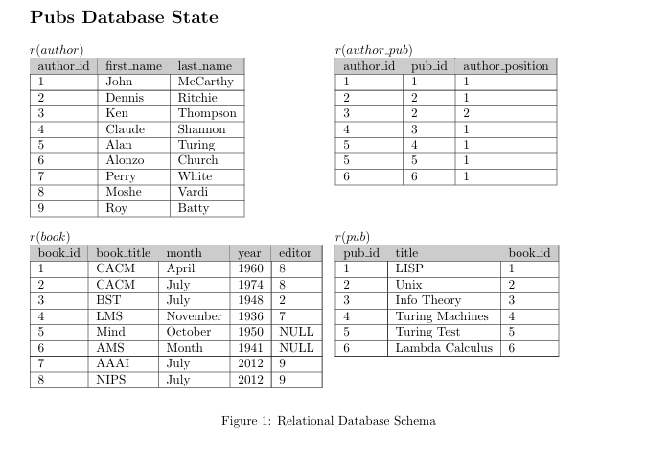
- How many tuples will be returned by the following relational algebra query?
- What question does the following expression answer?
- Write a relational algebra expression that returns the names of all authors who are book editors.
- Write a relational algebra expression that returns the names of all authors who are not book editors.
- Write a relational algebra expression that returns the names of all authors who have at least one publication in the database.
- How many tuples are returned by the following relational algebra expression?
- What question does the following relational algebra expression answer?

SOLUTIONS: DISCUSS IN TOMMAROW’S LECTURE

